**INTRODUCTION**

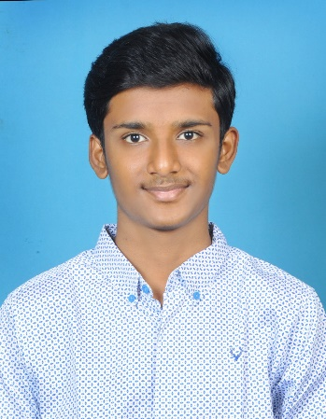

My name is Akshay Rachakonda, I am a B.Tech student pursuing Computer Science and Engineering. Currently in my second year at Malla Reddy University with a CGPA of 9.13. I hail from Siddipet, Telangana. I completed my secondary education from Sri Chaitanya school with 10 CGPA, Siddipet and my Intermediate in Narayana IIT Academy with 98%, Hyderabad. I am an avid learner, always eager to explore new concepts and stay updated with the latest advancements in the tech world. My hobbies include Browsing internet and exploring the new things outside with my friends, as well as listening to music. I am particularly very much interested in Web technologies and Logo Designing. I want to see myself as a person to work and engage with startup companies where I can share my experience with all the freshers also, I can learn and enhance new things from them. My goal is to leverage my technical expertise and creative problem-solving abilities to contribute effectively to the tech industry and make a meaningful impact.